**LAPORAN PRAKTIKUM**

**TESTING DOCUMENTATION & TEST CASE & TRACKING MANAGEMENT TOOLS (1)**

**Audyva Irefilevitasari Alifia**

Quality Engineer-A, Alterra

Email: audyvairefilevitasarialifia9@gmail.com

**Universitas Brawijaya**

Soal Testing Documentation

1. Soal Prioritas 1
2. Buatlah Test Case sebanyak mungkin pada fitur login, pilih produk sampai pilih metode pembayaran dari https://www.sepulsa.com/ dengan menggunakan format laporan yang sudah ditentukan. Letakkan kumpulan test case tersebut dalam bentuk file excel.

Jawab:

1. Scenario Login
2. (If&Result) Input invalid email and input no password

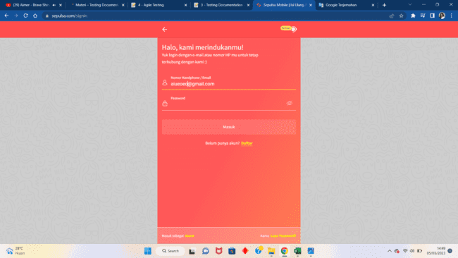

1. (If&Result) Input invalid phone number and input no password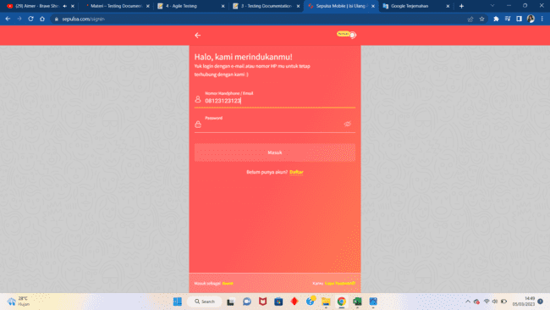
2. (If&Result) Input no email or phone number and input invalid password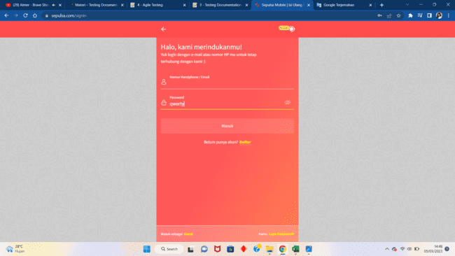
3. (If&Result) Input no email or phone number and input valid password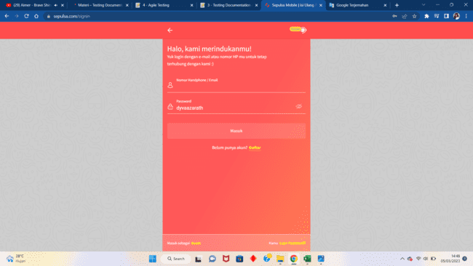
4. (If&Result) Input no email or phone number and no password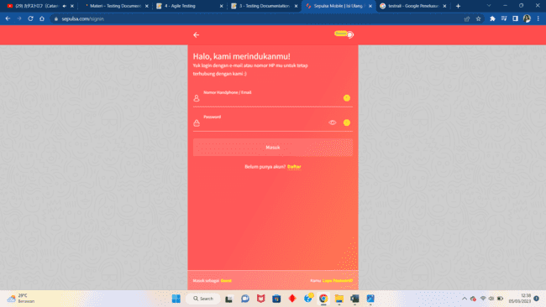
5. (If&Result) Input valid email and input no password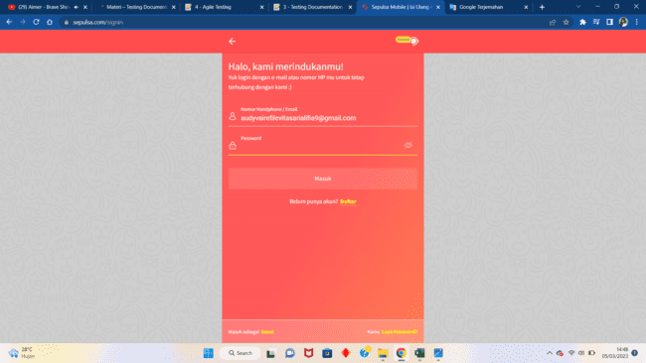
6. (If&Result) Input valid phone number and input no password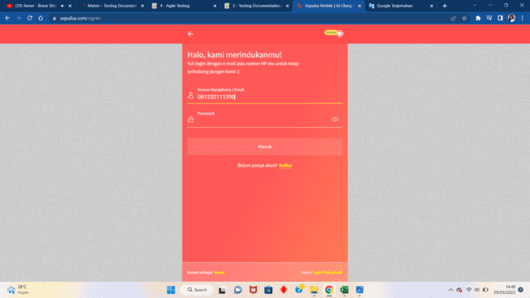
7. (If) Input invalid email and invalid password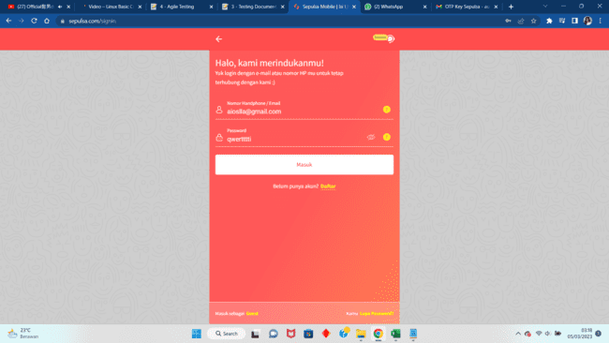
8. (If) Input invalid email and valid password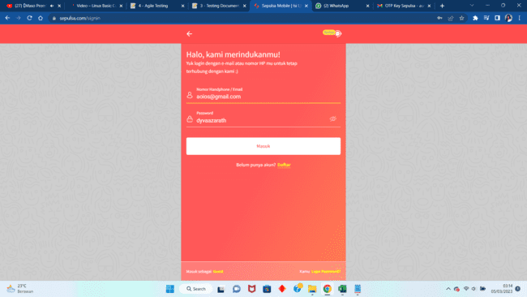
9. (If) Input invalid phone number and invalid password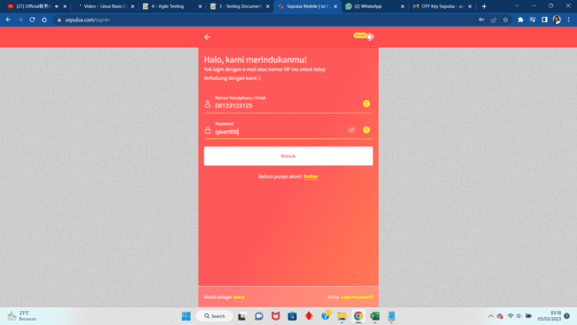
10. (If) Input invalid phone number and valid password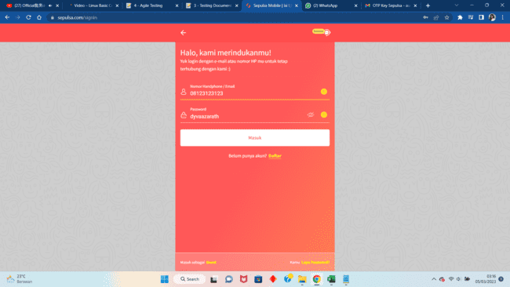
11. (If) Input valid email and invalid password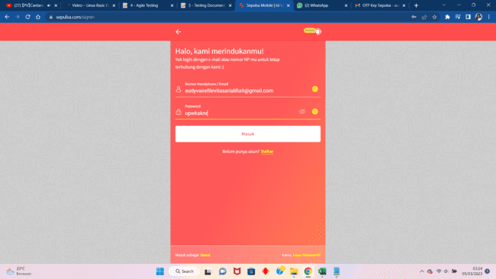
12. (If) Input valid email and valid password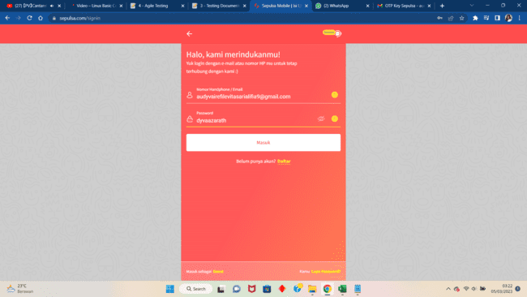
13. (If) Input valid phone number and invalid password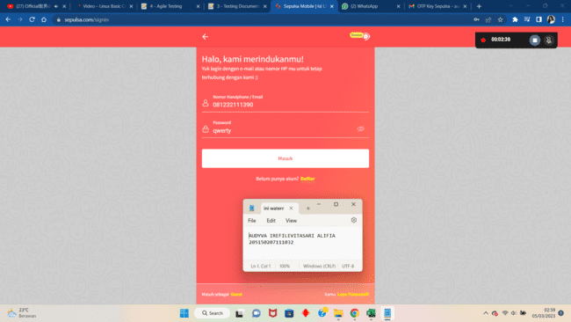
14. (If) Input valid phone number and valid password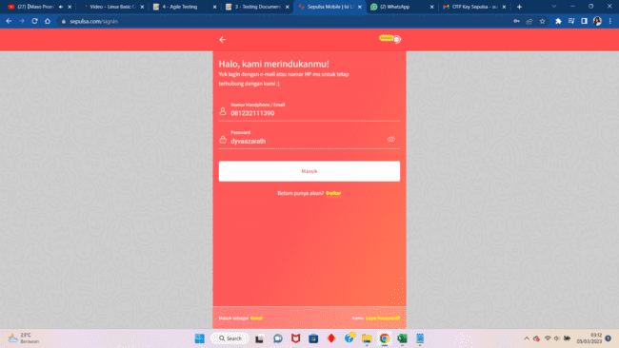
15. (Result) Input invalid email and invalid password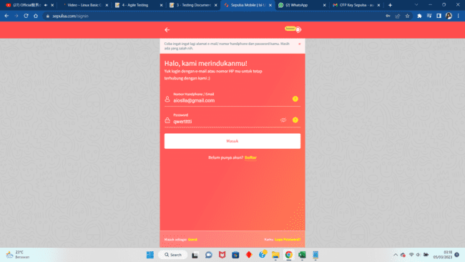
16. (Result) Input invalid email and valid password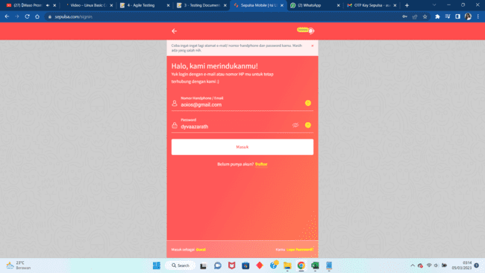
17. (Result) Input invalid phone number and invalid password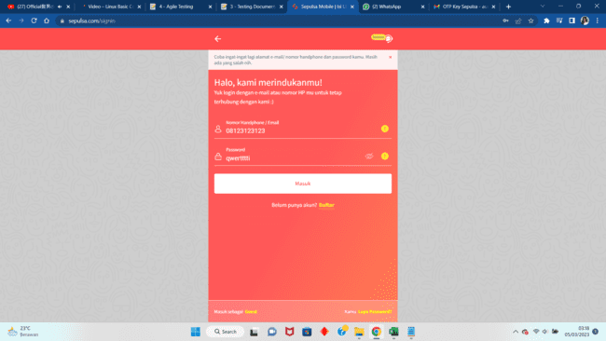
18. (Result) Input invalid phone number and valid password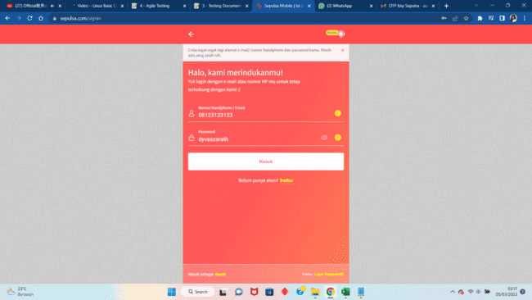
19. (Result) Input valid email and invalid password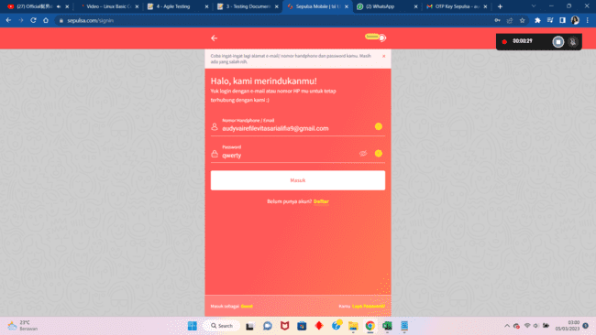
20. (Result) Input valid email and valid password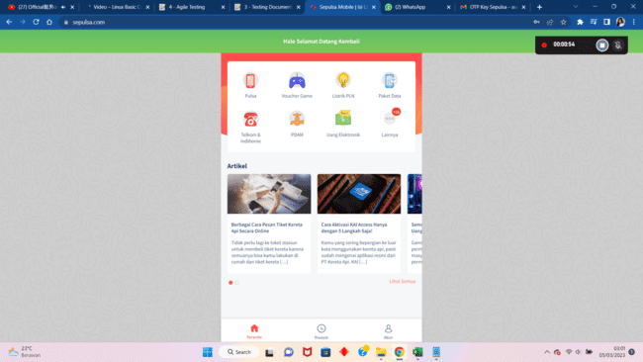
21. (Result) Input valid phone number and invalid password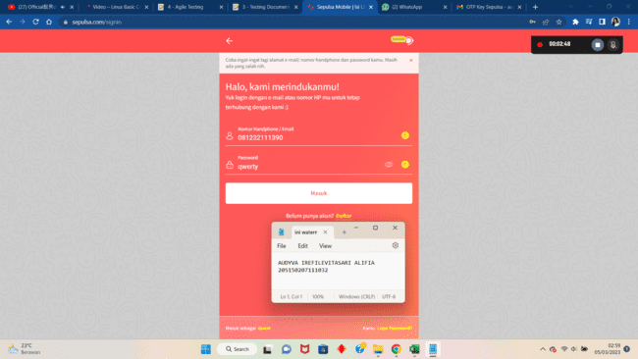
22. (Result) Input valid phone number and valid password
23. D
24. Scenario Pilih Produk
25. (Precondition-If) User has already logged in

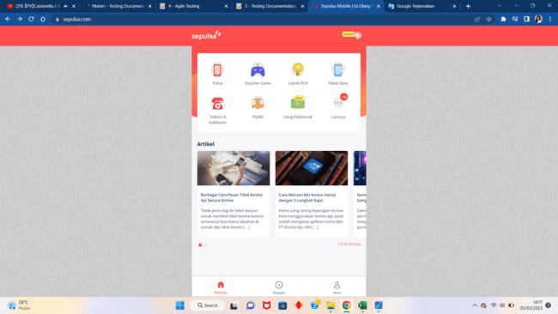

1. (Precondition-If) User not logged in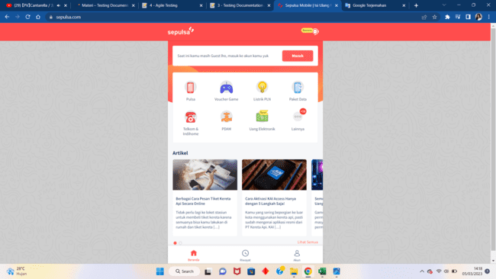
2. (Result) Choose Listrik PLN icon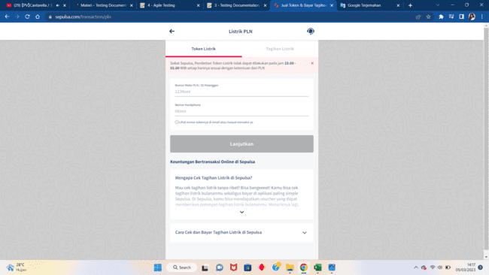
3. (Result) Choose Paket Data icon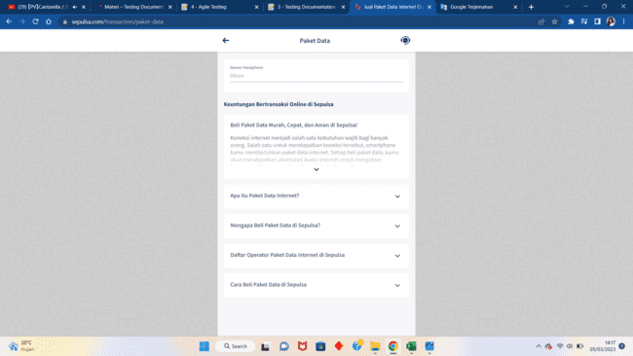
4. (Result) Choose PDAM icon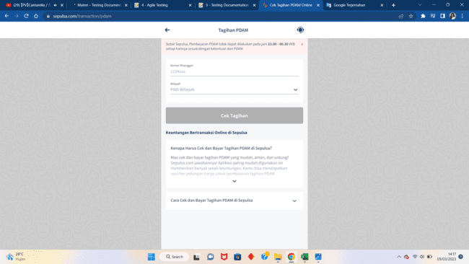
5. (Result) Choose Pulsa icon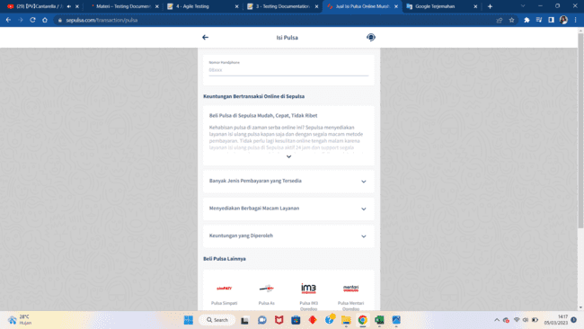
6. (Result) Choose Telkom & Indihome icon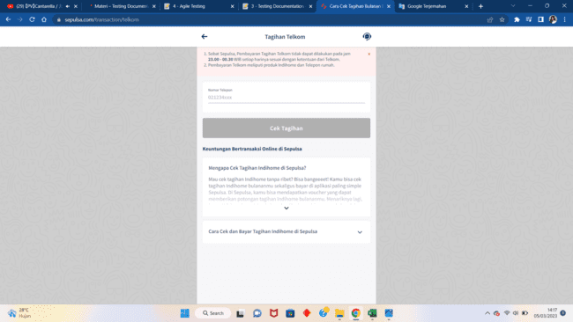
7. (Result) Choose Uang Elektronik icon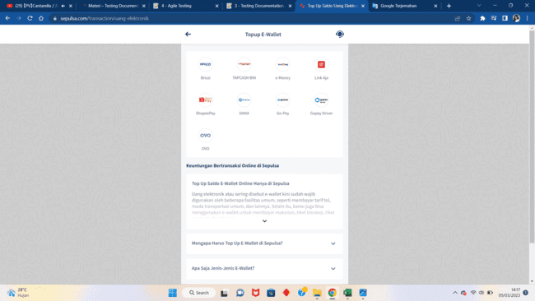
8. (Result) Choose Voucher Game icon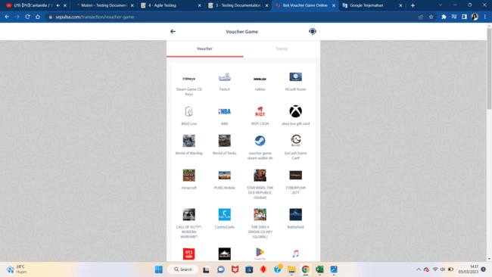
9. D
10. D
11. Scenario Isi Pulsa
12. (If&Result) Enter 10 digit zero number and already logged in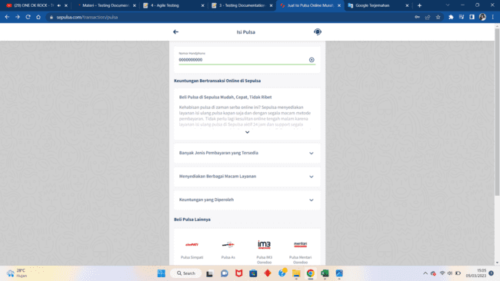
13. (If&Result) Enter non-Indonesian phone number and already logged in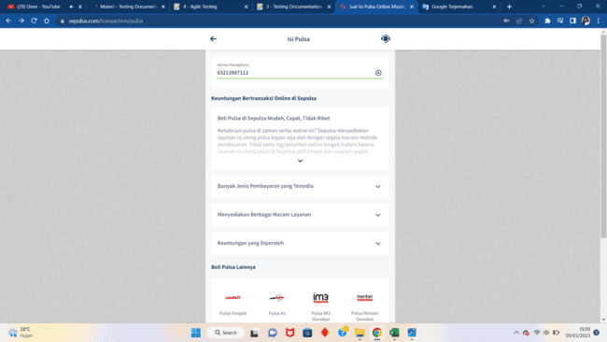
14. (If) Enter 4 digit Axis phone number and already logged in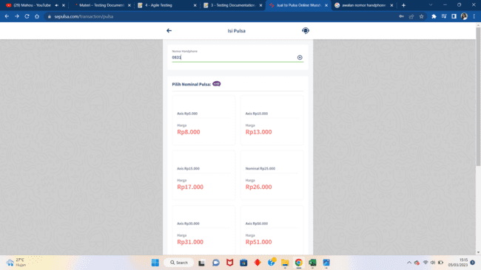
15. (If) Enter 4 digit Indosat phone number and already logged in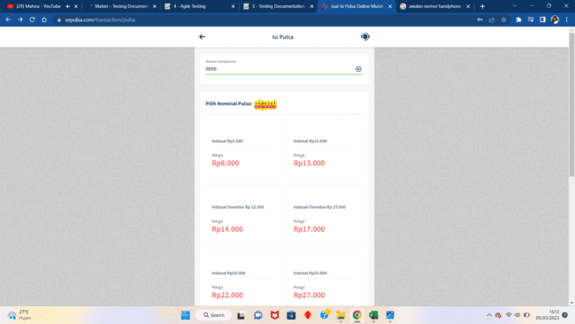
16. (If) Enter 4 digit Smartfren phone number and already logged in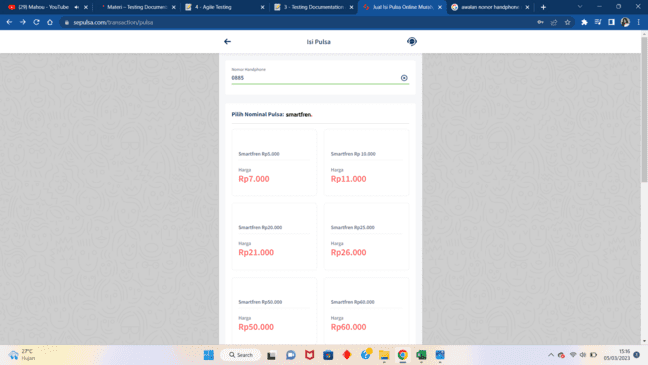
17. (If) Enter 4 digit Telkomsel phone number and already logged in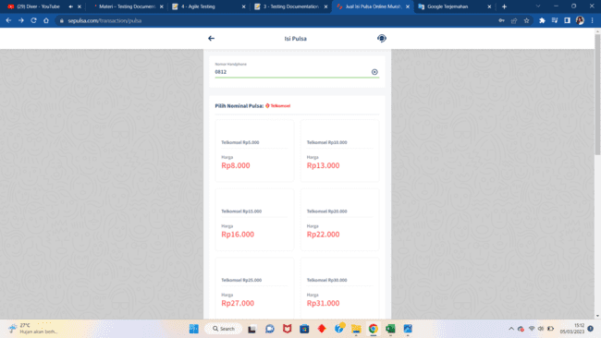
18. (If) Enter 4 digit Tri phone number and already logged in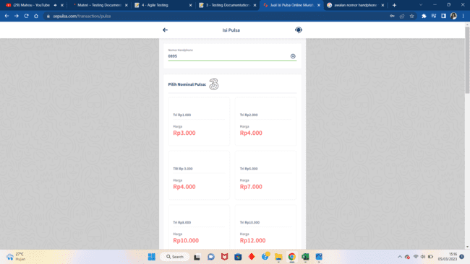
19. (If) Enter 4 digit XL phone number and already logged in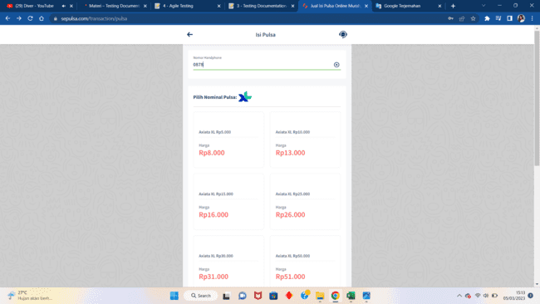
20. (If) Enter 10 digit invalid one of operator phone number and already logged in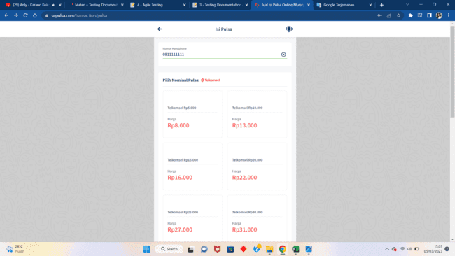
21. (If) Enter a valid phone number and already logged in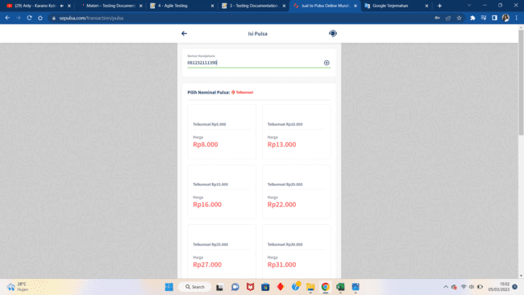
22. (If) Enter less than 10 digit invalid phone number and already logged in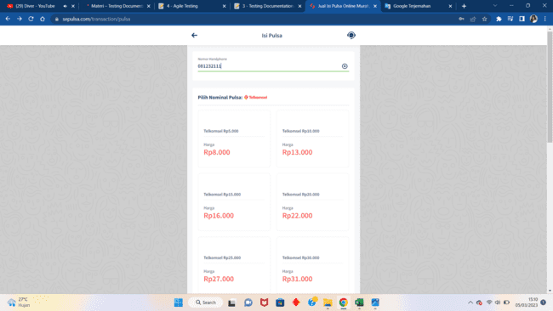
23. (If) Enter more than 13 digit invalid phone number and already logged in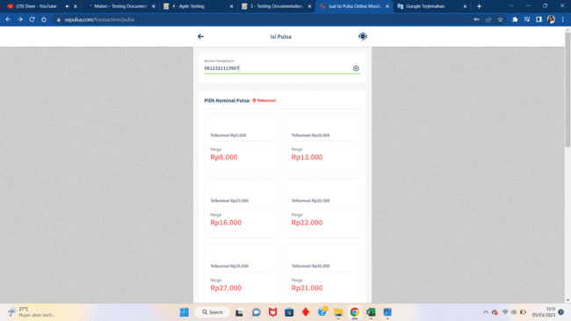
24. (Result) Enter 4 digit Axis phone number and already logged in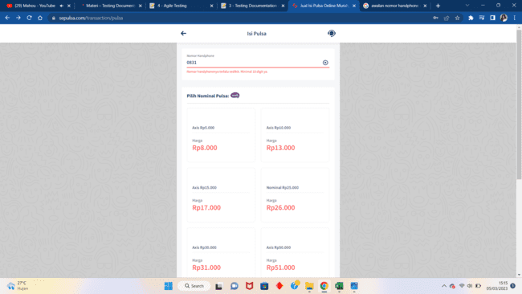
25. (Result) Enter 4 digit Indosat phone number and already logged in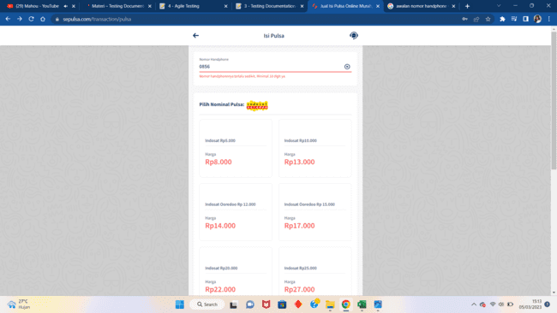
26. (Result) Enter 4 digit Smartfren phone number and already logged in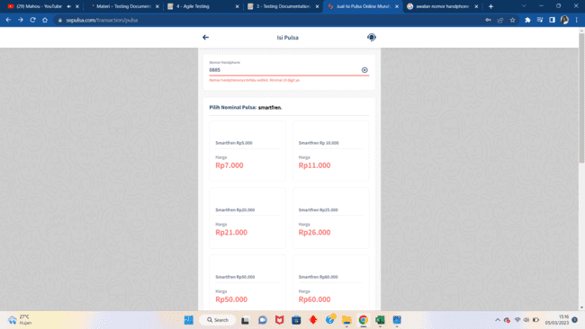
27. (Result) Enter 4 digit Telkomsel phone number and already logged in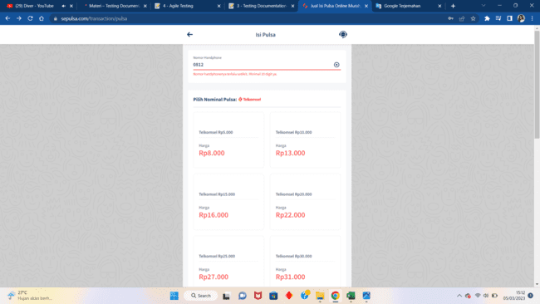
28. (Result) Enter 4 digit Tri phone number and already logged in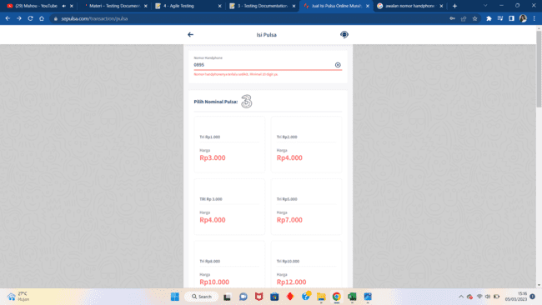
29. (Result) Enter 4 digit XL phone number and already logged in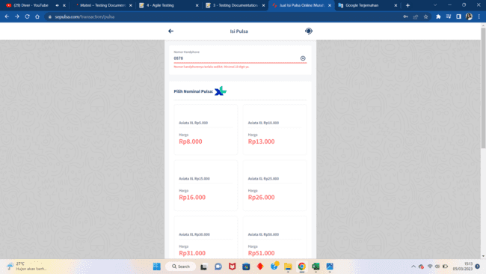
30. (Result) Enter 10 digit invalid one of operator phone number and already logged in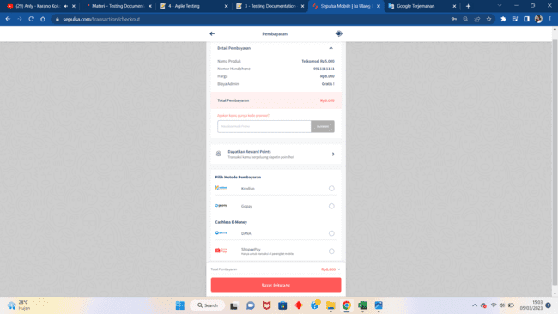
31. (Result) Enter a valid phone number and already logged in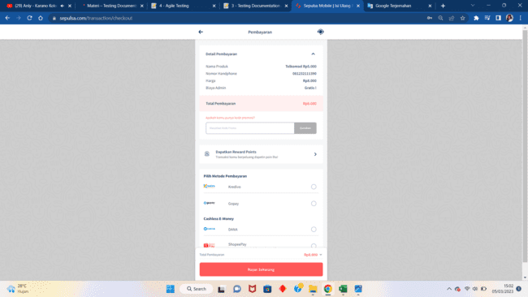
32. (Result) Enter less than 10 digit invalid phone number and already logged in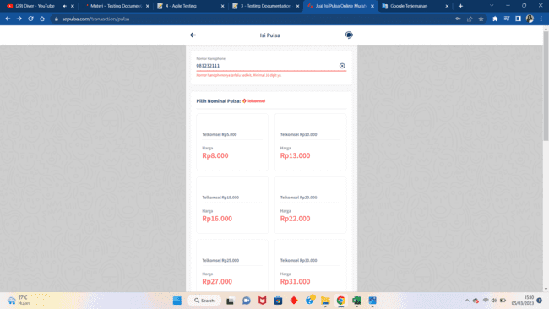
33. (Result) Enter more than 13 digit invalid phone number and already logged in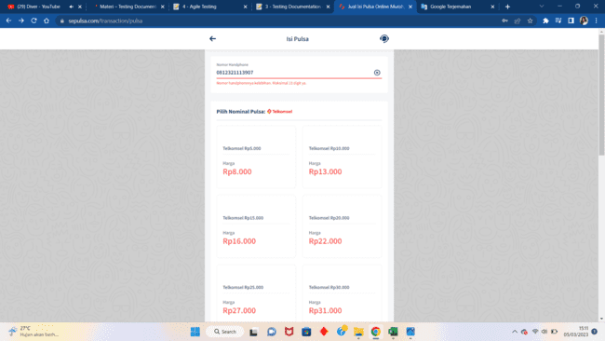
34. ss
35. ss
36. s
37. Scenario Pilih Metode Pembayaran
38. (If&Result) Input no email and choose DANA and not logged in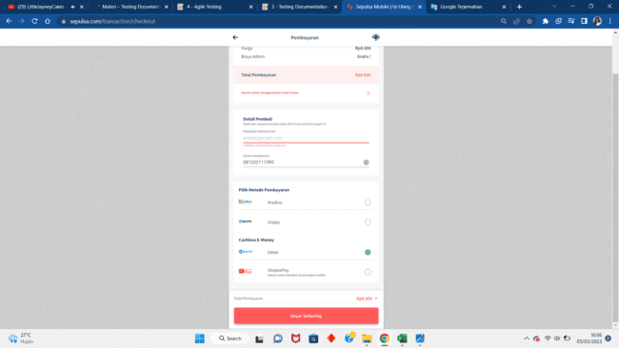
39. (If&Result) Input no email and choose Gopay and not logged in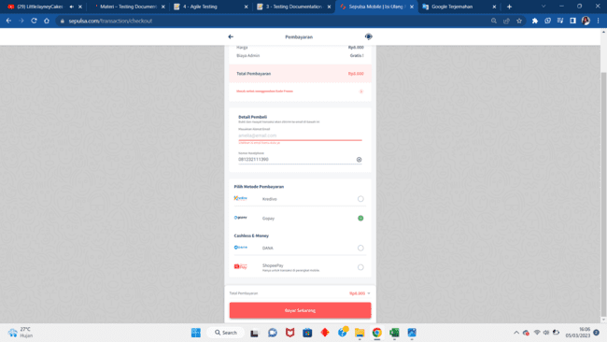
40. (If&Result) Input no email and choose Kredivo and not logged in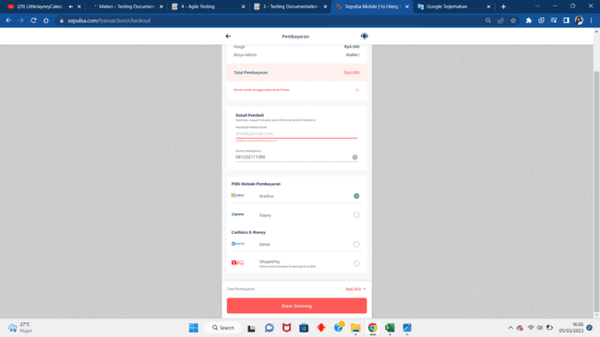
41. (If&Result) Input no email and choose Shoeepay and not logged in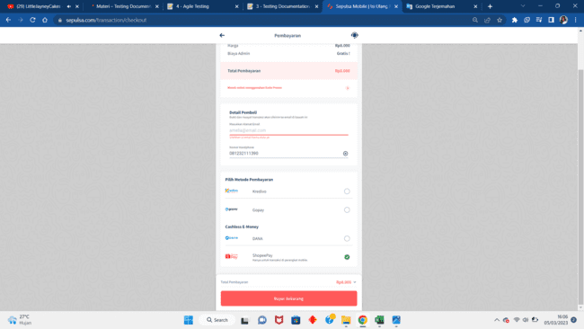
42. (If) Choose DANA and already logged in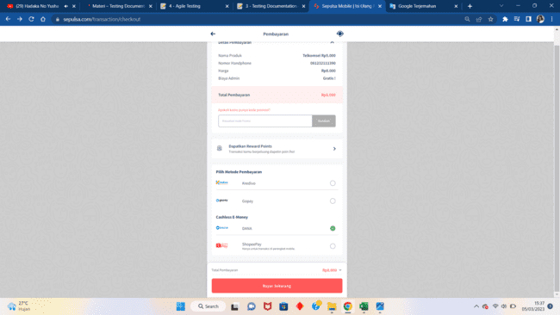
43. (If) Choose Gopay and already logged in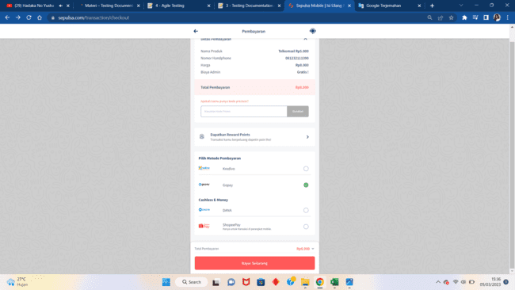
44. (If) Choose Kredivo and already logged in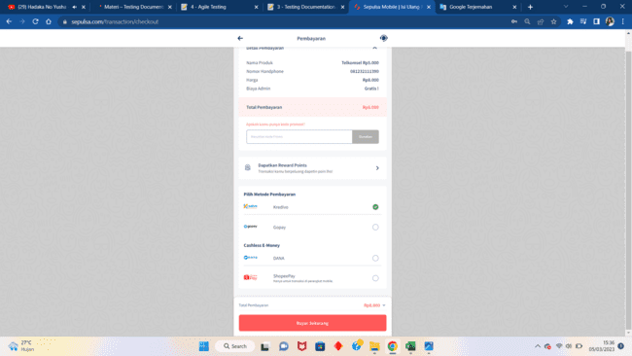
45. (If) Choose ShopeePay and already logged in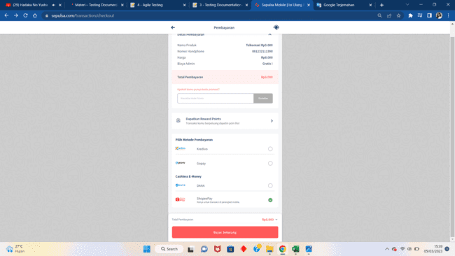
46. (If) Input invalid email and choose DANA and not logged in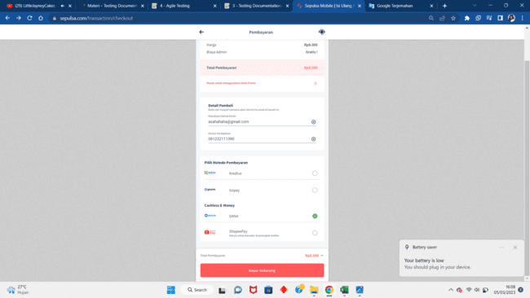
47. (If) Input invalid email and choose Gopay and not logged in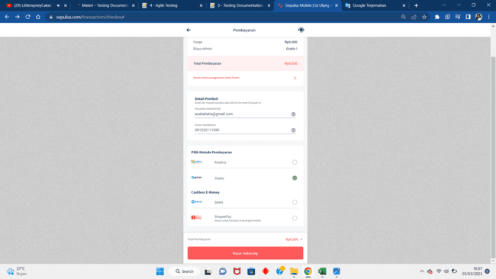
48. (If) Input invalid email and choose Kredivo and not logged in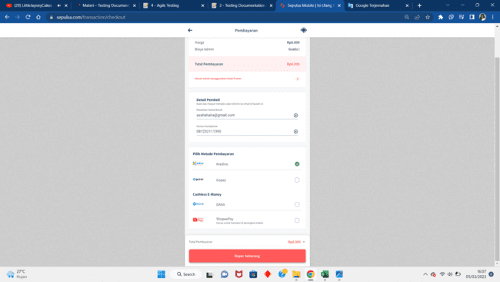
49. (If) Input invalid email and choose Shopeepay and not logged in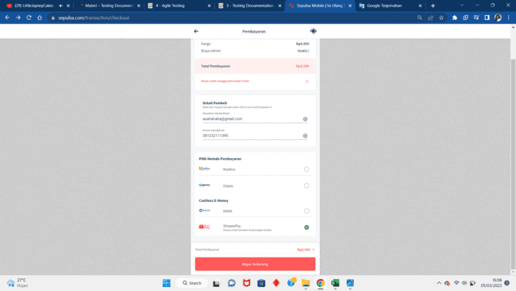
50. (If) Input valid email and choose DANA and not logged in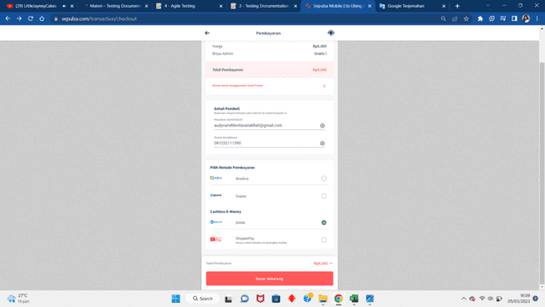
51. (If) Input valid email and choose Gopay and not logged in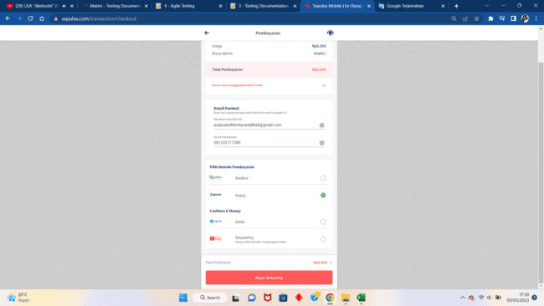
52. (If) Input valid email and choose Kredivo and not logged in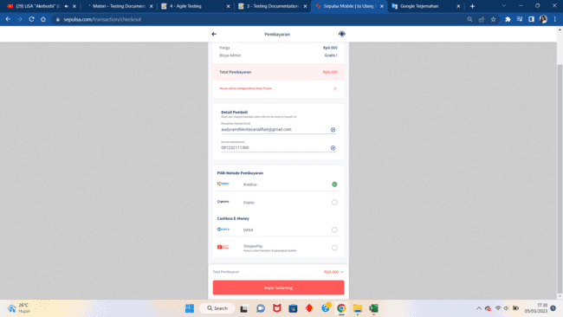
53. (If) Input valid email and choose ShopeePay and not logged in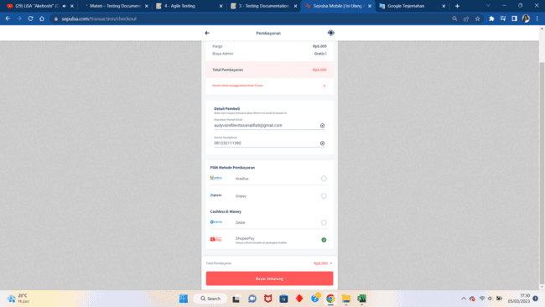
54. (Result) Choose DANA and already logged in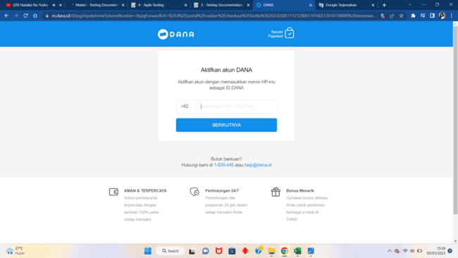
55. (Result) Choose Gopay and already logged in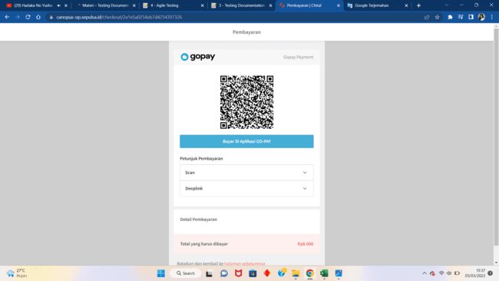
56. (Result) Choose Kredivo and already logged in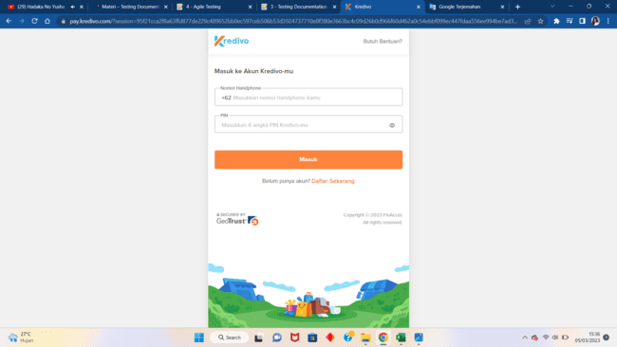
57. (Result) Choose ShopeePay and already logged in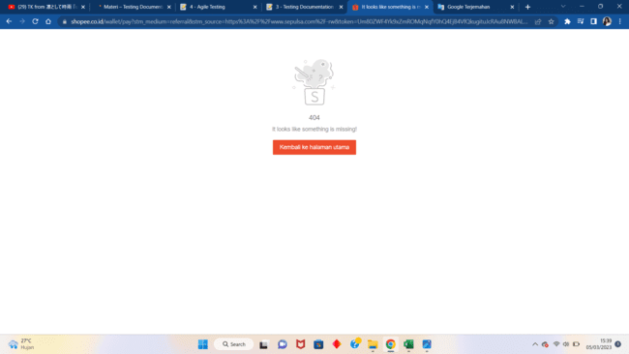
58. (Result) Input invalid email and choose DANA and not logged in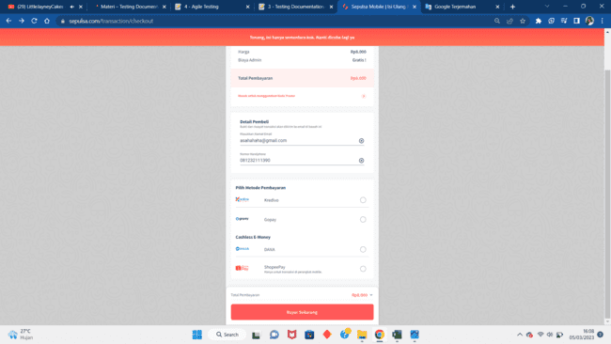
59. (Result) Input invalid email and choose Gopay and not logged in
60. (Result) Input invalid email and choose Kredivo and not logged in
61. (Result) Input invalid email and choose Shopeepay and not logged in
62. (Result) Input valid email and choose DANA and not logged in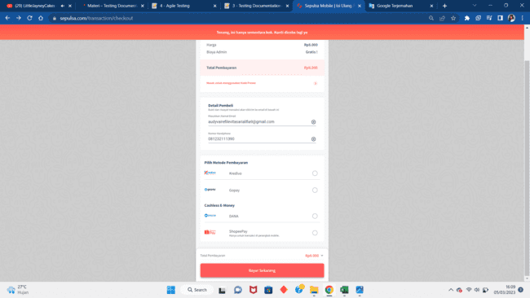
63. (Result) Input valid email and choose Gopay and not logged in
64. (Result) Input valid email and choose Kredivo and not logged in
65. (Result) Input valid email and choose Shopeepay and not logged in

**Link File Excel Soal Prioritas 1:** [Soal Prioritas 1_Audyva Irefilevitasari Alifia.xlsx](https://docs.google.com/spreadsheets/d/1ExDt2lYplXCL7RHtz3vF1Np-3RskaXY-/edit?usp=sharing&ouid=111443044022227946979&rtpof=true&sd=true)

1. K
2. **Soal Prioritas 2**
3. Buatlah test case untuk aplikasi<https://www.sepulsa.com/> untuk fitur register, lihat artikel dan lihat riwayat transaksi dengan menggunakan format laporan yang sudah ditentukan. Letakkan kumpulan test case tersebut dalam bentuk file excel.

Jawab:

1. Scenario Register
2. (If&Result) one or more of fill-required field blank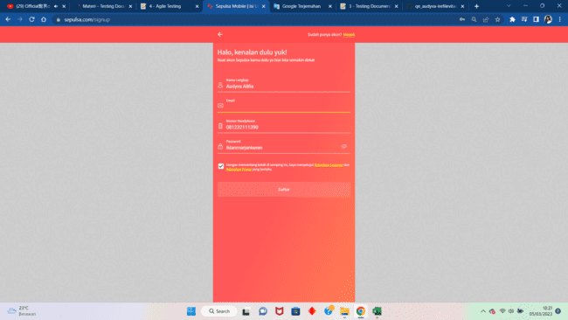
3. (If) Input already existed email in database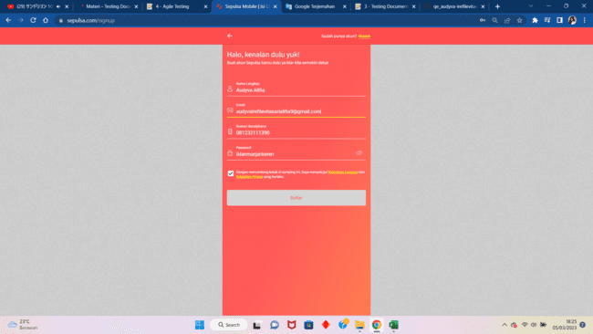
4. (If) Input already existed phone number in database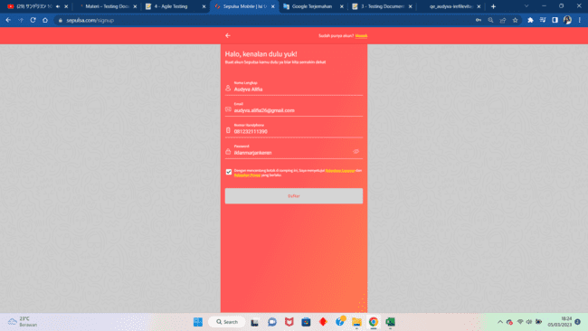
5. (If) Input already existed user's Full Name in database and input new email and phone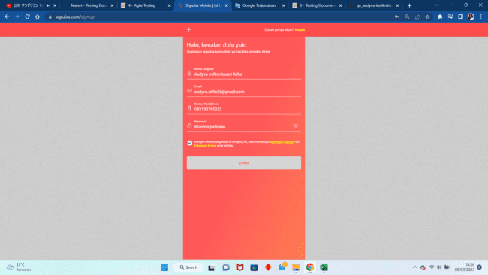
6. (If) Input different name, phone number, and email from the existed one in database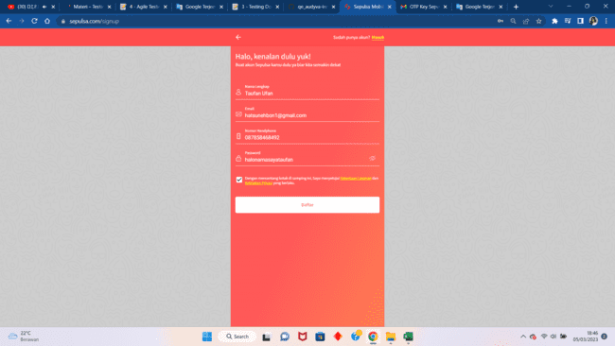
7. (If) Input non-email text in email field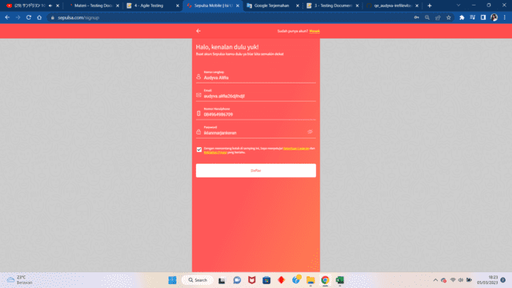
8. (If) Input true verification code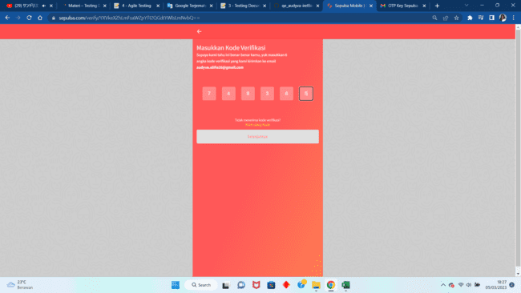
9. (If) Input wrong verification code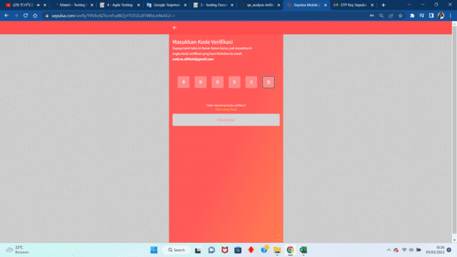
10. (Result) Input already existed email in database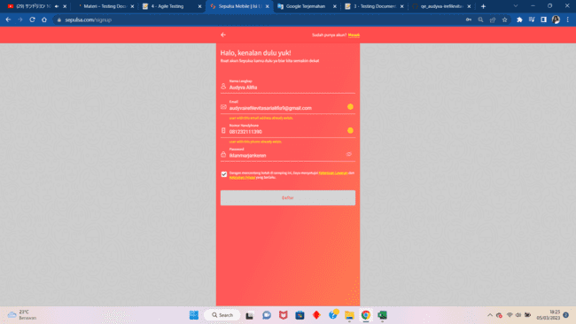
11. (Result) Input already existed phone number in database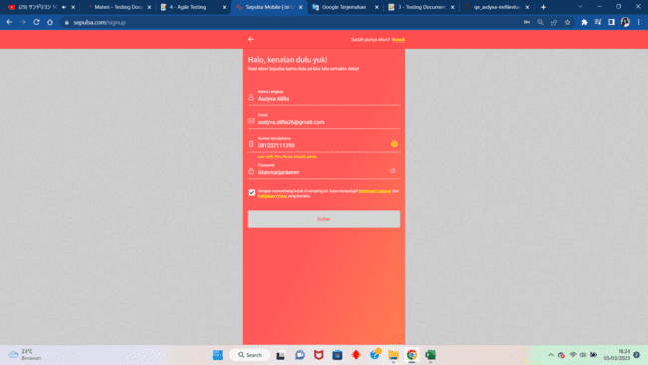
12. (Result) Input already existed user's Full Name in database and input new email and phone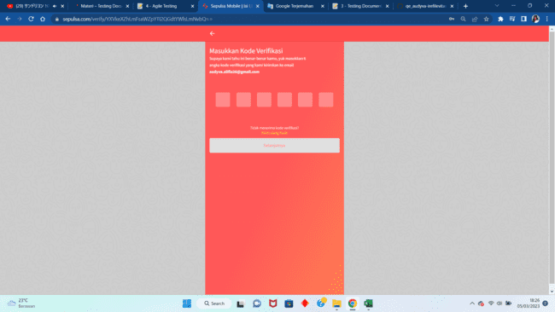
13. (Result) Input different name, phone number, and email from the existed one in database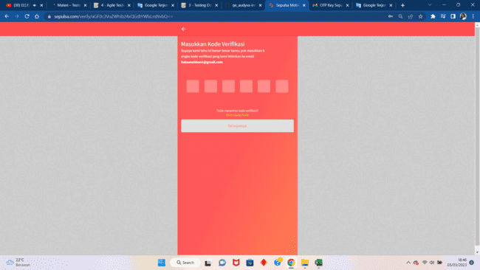
14. (Result) Input non-email text in email field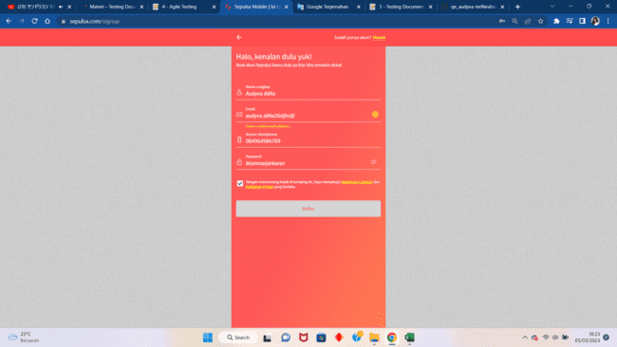
15. (Result) Input true verification code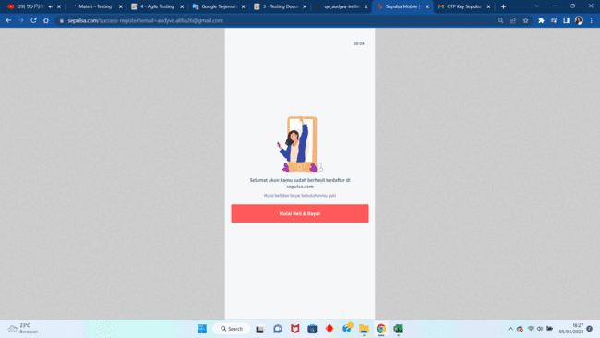
16. (Result) Input wrong verification code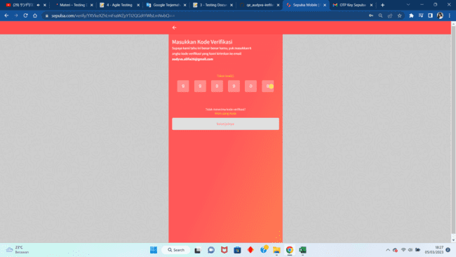
17. Scenario Lihat Artikel
18. (Precondition-If) User already logged in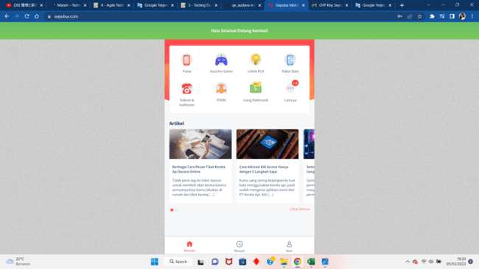
19. (Precondition-If) User not logged in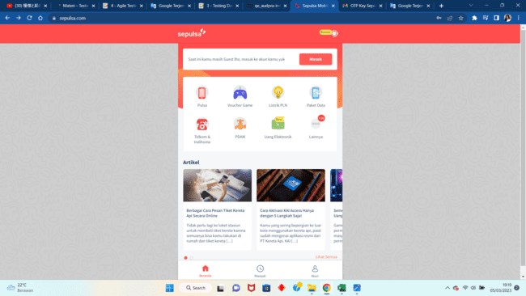
20. (Result) clicked one article and already logged in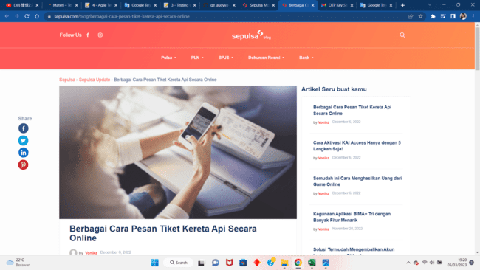
21. (Result) clicked one article and not logged in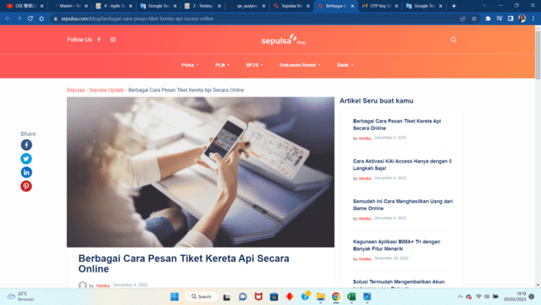
22. Scenario Lihat Riwayat Transaksi
23. (Precondition-If) User already logged in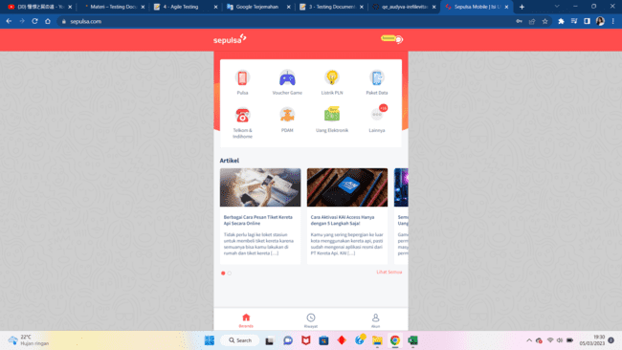
24. (Precondition-If) User not logged in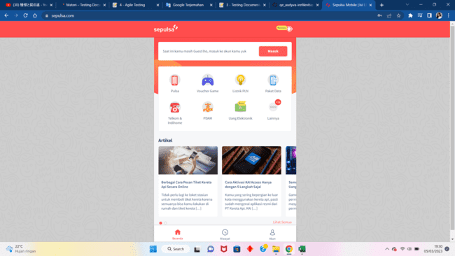
25. (Result) User clicked the Riwayat menu and already logged in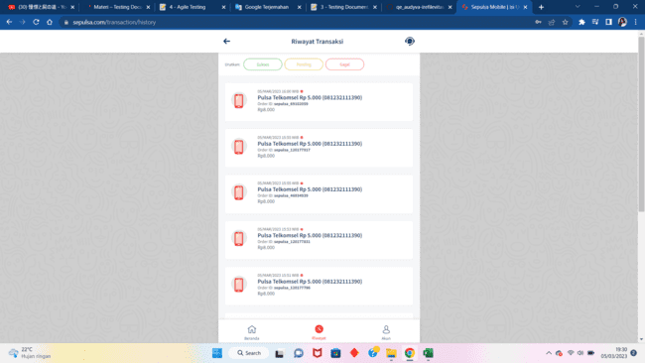
26. (Result) User clicked the Riwayat menu and not logged in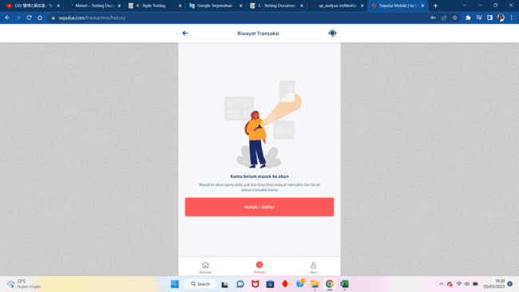

**Link File Excel Soal Prioritas 2:** [Soal Prioritas 2_Audyva Irefilevitasari Alifia.xlsx](https://docs.google.com/spreadsheets/d/1Y655M9_kCO7W8DJyo_Fbj1RWfygsziZR/edit?usp=share_link&ouid=111443044022227946979&rtpof=true&sd=true)

1. S
2. **Soal Eksplorasi**
3. Lakukan pengujian non fungsional untuk aplikasi<https://www.sepulsa.com/> dengan menggunakan Lighthouse. Referensi mengenai Lighthouse dapat dicek di link [berikut](https://developer.chrome.com/docs/lighthouse/overview/). Kriteria untuk pengujian non fungsional adalah sebagai berikut:
4. Terdapat pengujian non fungsional untuk tampilan di web dan mobile.
5. Terdapat screenshot hasil pengujian untuk 2 platform (web dan mobile) beserta penjelasan dari hasil pengujian yang telah dilakukan.
6. Hasil pengujian ditulis dalam google docs.
7. Contoh hasil pengujian dengan menggunakan Lighthouse adalah sebagai berikut:

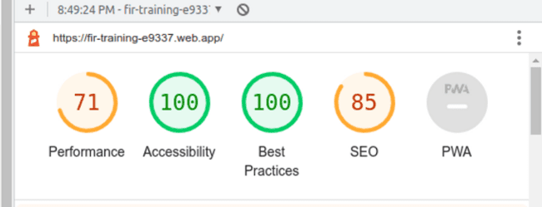

Jawab:

1. Screenshots
2. Platform web

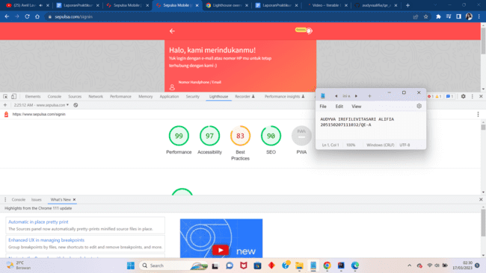

1. Platform mobile

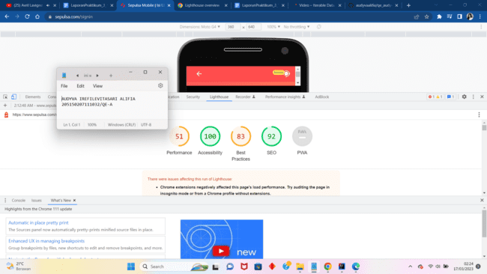

1. Hasil Pembahasan

Berdasarkan pengujian menggunakan Lighthouse, didapatkan bahwa performa Sepulsa pada platform web jauh lebih baik daripada digunakan di platform mobile. Didapatkan 51% performance pada mobile dimana angka ini hanya separuh dari sempurna sedangkan didapatkan 99% performance pada web dimana angka ini sangat mendekati sempurna. Kemudian selisih aksesibilitas pada mobile lebih tinggi 3% dimana keduanya sama-sama memiliki aksesibilitas yang sudah sangat baik: 97% dan 100%. Selanjutnya, kedua platform menunjukkan angka yang sama pada best practices yakni sebesar 83%. terakhir, pada bidang Search Engine Optimization, platform web mendapatkan nilai 2% lebih tinggi daripada platform web dimana keduanya memiliki angka yang sangat baik yaitu 90% dan 92%.